MMS

Software Requirements Specification

Version <1.0>

Software Requirements Specification

Introduction

The introduction of the Software Requirements Specification (SRS) provides an overview of the entire SRS with purpose, scope, definitions, acronyms, abbreviations, references and overview of the SRS. The aim of this document is to gather and analyze and give an in-depth insight of the Meeting Minutes Summarizer Application by defining the problem statement in detail.

Purpose

The purpose of the document is to collect and analyze all assorted ideas that have come up to define the system, its requirements with respect to consumers. Also, we shall predict and sort out how we hope this product will be used in order to gain a better understanding of the project, outline concepts that may be developed later, and document ideas that are being considered, but may be discarded as the product develops.

In short, the purpose of this SRS document is to provide a detailed overview of our software product, its parameters and goals. This document describes the project's target audience and its user interface, hardware and software requirements. It defines how our client, team and audience see the product and its functionality. Nonetheless, it helps any designer and developer to assist in software delivery lifecycle (SDLC) processes.

Scope

Primarily, the scope pertains to the features of Meeting Minutes Summarizer. //point to functional and non functional.

Definitions, Acronyms, and Abbreviations

FAQ | Frequently Asked Questions
User | Someone who interacts with the application
MMS | Meeting Minutes Summarizer

References
The references are:

[1] IEEE Software Engineering Standards Committee, “IEEE Std 830-1998, IEEE Recommended Practice for Software Requirements Specifications”, October 20, 1998.
[2] Wiegers, Karl, Software Requirements (3rd Edition), Microsoft Press 2013
[3] Standardized Statement Templates – beginning to write SRS
Link: https://www.coursera.org/learn/srs-documents-requirements/lecture/1o2v0/standardized-statement-templates

Overview

The remaining sections of this document provide a general description, including characteristics of the users of this project, the product's hardware, and the functional and data requirements of the product. General description of the project is discussed in section 2 of this document. Section 3 gives the functional requirements, data requirements and constraints and assumptions made while designing the E-Store. It also gives the user viewpoint of product. Section 3 also gives the specific requirements of the product. Section 3 also discusses the external interface requirements and gives detailed description of functional requirements. Section 4 is for supporting information.

Overall Description
2.1 Product Overview

MMS aims to increase the efficiency of users by helping them to fully focus on conversation without worrying about taking notes. Users do not lose track of conversations and participate actively in discussions. They will open the app in the mobile phone and start the recording. When the recording stops, the audio is converted into text. MMS not just gives the text format of meeting but also presents the concise summary. It saves the summary of your meeting which you may recall later. For example, if you are sitting in a meeting and want to focus on discussions rather making notes simultaneously, just open the MMS application and let it create notes on your behalf.

2.2 Similar System Information

1) Otter Voice Meeting Notes for English: Otter is a voice to text converter app. It takes audio as an input and converts it in the text form. It is a commercial product and gives only 600 free minutes for a month. It saves the notes and has a share option, using that option one can share notes directly to his teammates. It is not an open-source application.
2) Braina: It offers various services. Making notes from voice recording is one of their popular service. It is commercial product and offers very few and limited services in unpaid version. It has specific requirements like it works on windows 10, 8.1, 8 and 7 only. Briana does not make summary of the meeting.
3) Amazon Transcribe: This is also a commercial service on cloud. It comes with the AWS cloud services. It takes a voice notes and produces the transcribes of voice notes. In order to use this service one will need to buy the cloud service. Good thing about this service is that it provides many categories in voice to text conversion like a customized service for medical audio etc. It misses the summary making feature.
4) ListNote Pro NotePad: It is also a paid service. It is a little different from the former services because it has an option to record the audio and convert it to text on the fly. Its interface is enriched with many editing and formatting options. It is a useful app if you want to make notes of your lecture, but it also misses the summary making feature.
5) Deep Talk: It transcribes your conversations on the fly. deepTalk will generate a transcript enriched with speaker identification and voice separation, allowing you to understand exactly who said what. Like all the above-mentioned services, it is also paid. They have built their own algorithm, SumMeet, which extracts and presents the necessary actions, decisions, and insights and creates a summary. Deep talk predicts the intensity of the conversation as low, medium, or high. Deep talk automatically adds topics after the conversation has ended.

Apart from the above services there are many other services available too. 6) Reason8, 7) Penman, 8) Dragon, 9) SpeechNotes, 10) SpeechTexter and 11) Azure cloud services and 12) IBM cloud services are among them.
All the above services share a common problem that they are all commercial. Some of them offer free versions but with very limited services and limited conversation time. Furthermore, most of them do not have a feature for making summary.

2.3 User Characteristics

MMS is intended to be used by people participating in a meeting. A typical user should have some experience using mobile applications and mobile operating systems.

2.4 User Problem Statement

It is difficult to participate in a meeting and write meeting minutes at the same time.

Specific Requirements

The specific requirements are –

Functionality

Introduction –

This subsection contains the requirements for MMS. Features then refined into use case diagrams and to sequence diagram to best capture the functional requirements of the system.

The app will record live audio conversation.

After tapping record icon the user will input meeting information and then start the recording.

The user will input number of speakers before recording starts

The recording can only be started by clicking the record icon on home page.

Pause a meeting

Tapping pause will pause the meeting (no transcription created)

Provide live transcriptions of the audio conversation recorded

As the recording progress live transcriptions along with time stamps will be shown on the screen.

Provide a summary of the meeting audio conversation

After user clicks stop icon user will be redirected to a new page. With meeting detail, followed by summary, and then a bar tapping which will redirect to a page with the meeting transcription.

Allow the user to edit meeting details

In the page where summary is, there is a edit button on the top. Clicking this will allow the user to edit meeting details.

Allow the user to edit voice transcription

In the page where voice transcriptions are present, there is a edit button on the top. Clicking this will allow the user to edit transciptions details.

Allow the user to recreate summary after editing transcriptions

After editing transcriptions the user will be shown an option to recreate summary. Clicking this will recreate the summary and overwrite (if selected) the previous one.

Allow the user to share a meeting

Meeting details, summary and transcription will be shared as a text file.

Allow the user to delete a meeting

Meeting details, summary, as well as transcriptions for that meeting will be deleted.

Usability

Graphical User Interface

The system shall provide a uniform look and feel between all the app pages.

There will be bar to create a new meeting, and icons to pause or stop one if the user wants to end meeting.

There will be a no menu bar, as the number of screen are limited.
All pages other than home will have a home icon at the top left.

Reliability & Availability

Back-end Internal Computers

The app will be using google cloud backend for computation maintenance. It will use SQLite database for storing in app information in the mobile device.

Performance

The product shall be based on web and will be run from a web server.

The product shall take initial load time depending on internet connection strength which also depends on the media from which the product is run.

The performance shall depend upon hardware components of the user.

Supportability

Configuration Management Tool

The app will be built using native android Studio and will support all android version 9.0 and greater.

Design Constraints

Standard Development Tools

The app will be made using Android Studio and use Java as the programming language.

Web Based Product

The mobile should have sufficiently fast internet connection.
The microphone should not be blocked while recording a meeting.

Interfaces

User Interfaces

Insert wire frames and prototype screenshots here.

Hardware Interfaces
The app is designed for android phones with version 9.0 or higher.

Communications Interfaces

The application will utilize the networking hardware of the user’s device through network communications services provided by the Android operating system.

Legal, Copyright, and Other Notices

IBA GNU

Performance Requirements
The mobile device should be fast enough to process a second of audio stream to be immediately uploaded to server.

System
The application will run on all Android devices running 9.0 or later.

Response Time
The application should not take more than 4 seconds to start.
The application should show transcriptions in less than one second of the first phrase completed.

Workload
The application must support at least 2 different speakers at the time of launch.

Use-ability
The app should be easy to understand and navigate.

Reliability
Application should provide feedback for each action. Either the page should change after an action. Or the icon pressed should change.
Call interrupts should not change the state of the app. If a call interrupts the meeting, the meeting should be set to pause and will have to manually be set to play.

Use Cases

Use Case Name: | Create new meeting
Actors: | End User
Description: | The user will be able to start a new meeting recording
Trigger: | Tap the voice record icon
Preconditions: | 1.End user shall own a personal smart mobile phone or a personal device that supports internet connectivity.  2. End user is at the homepage with no meeting in progress
Postconditions: | A summary as well as transcriptions are created and saved.
Normal Flow: | 1.0 User taps record button  2.0 User provides his meeting title, number of speakers and optionally name of speakers and comments.  3.0 User clicks stop the meeting stops and it ends  4.0 Application creates a summary and redirects user to a page with the summary and meeting details showing.
Alternative Flows:  [Alternative Flow 1 – Not in Network] | 2.1. User gets a pop up no internet connectivity  2.2 Meeting will not start until internet connectivity is confirmed.
Exceptions: | 2E. No meeting title inserted  -2E1. Displays an error message

Use Case Name: | View all meetings
Actors: | End User
Description: | The user will be able to browse through all the previous meetings
Trigger: | Tap view meetings
Preconditions: | The user is not currently recording a meeting.
Postconditions: | A webpage where all previous meeting are shown
Normal Flow: | - User taps menu button  - User taps meetings button  2.0 User is shown a list of all meetings with their titles
Alternative Flows: | 2.1. User has no meetings.  2.2 User is shown the message you have no meetings would you like to record one.

Use Case Name: | Edit meeting details
Actors: | End User
Description: | The user will be able to edit meeting title, speakers, comments.
Trigger: | Tap the edit button
Preconditions: | 1.End user is at the meeting summary page.  2. End user has no meeting in progress
Postconditions: | Meeting details are changed.
Normal Flow: | 1.0 User taps edit icon  2.0 User will edit any text field.  3.0 User clicks save.
Alternative Flows:  [Alternative Flow 1 – Not in Network] | 2.1.
Exceptions: | 2E. User makes leaves meeting title empty and then tries to save  -2E1. Displays an error message: Meeting title cannot be empty.

Use Case Name: | Edit transcriptions
Actors: | End User
Description: | The user will be able to edit transcriptions
Trigger: | Tap the edit button
Preconditions: | 1.The user is at the page with transcriptions showing  2. End user no meeting in progress
Postconditions: | Transcriptions are edited
Normal Flow: | 1.0 Edit the transcriptions  2.0 Click save
Alternative Flows:  [Alternative Flow 1 – Not in Network] | 2.1.
Exceptions: | 2E. User deletes all transcription  -2E1. Displays an error message

Use Case Name: | Recreate summary
Actors: | End User
Description: | The user will be able to recreate the summary
Trigger: | Tap the recreate summary option
Preconditions: | 1.User has edited the transcriptions  2. End user has no meeting in progress  3. User is connected to the internet
Postconditions: | A summary as well as transcriptions are created.
Normal Flow: | 1.0 User taps recreate summary  2.0 Web server receives request and creates a new summary
Alternative Flows:  [Alternative Flow 1 – Not in Network] | 2.1. User gets a pop up no internet connectivity  2.2 Cannot recreate summary because of no internet connectivity.
Exceptions:

Use Case Name: | Share a meeting
Actors: | End User
Description: | The user will be able to share meeting details, summary and transcriptions.
Trigger: | Tap the share button
Preconditions: | 1.User is on the meeting page that they want to share.  2. User has internet connectivity.
Postconditions: | Meeting details, summary and transcriptions are shared
Normal Flow: | 1.0 User taps share button  2.0 User selects checkbox that they want to share transcriptions.  3.0 A txt file is shared with meeting details, followed by summary and then, if selected, followed by transcriptions/
Alternative Flows:  [Alternative Flow 1 – Not in Network] | 2.1. User gets a pop up no internet connectivity
Exceptions:

Use Case Name: | Delete a meetings
Actors: | End User
Description: | The user will be able to delete a meeting
Trigger: | Tap view meetings
Preconditions: | The user is not currently recording a meeting.  The user has at least one meeting
Postconditions: | Meeting will be deleted
Normal Flow: | 1.0 User taps delete button on meeting page  2.0 User is redirected to home page
Alternative Flows:

Sequence Diagram
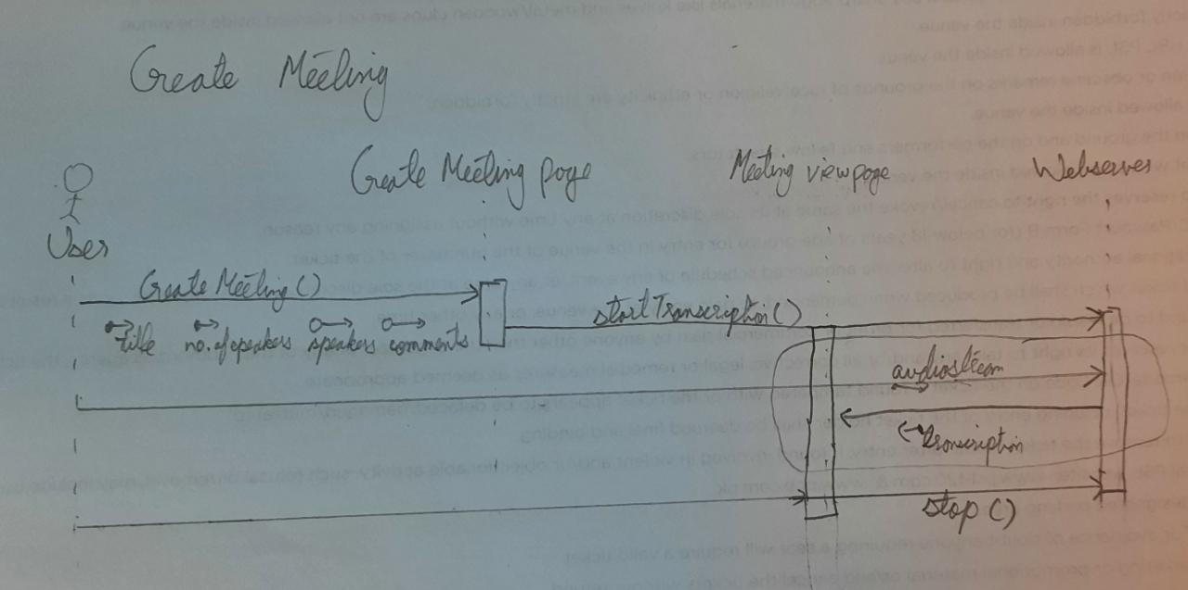

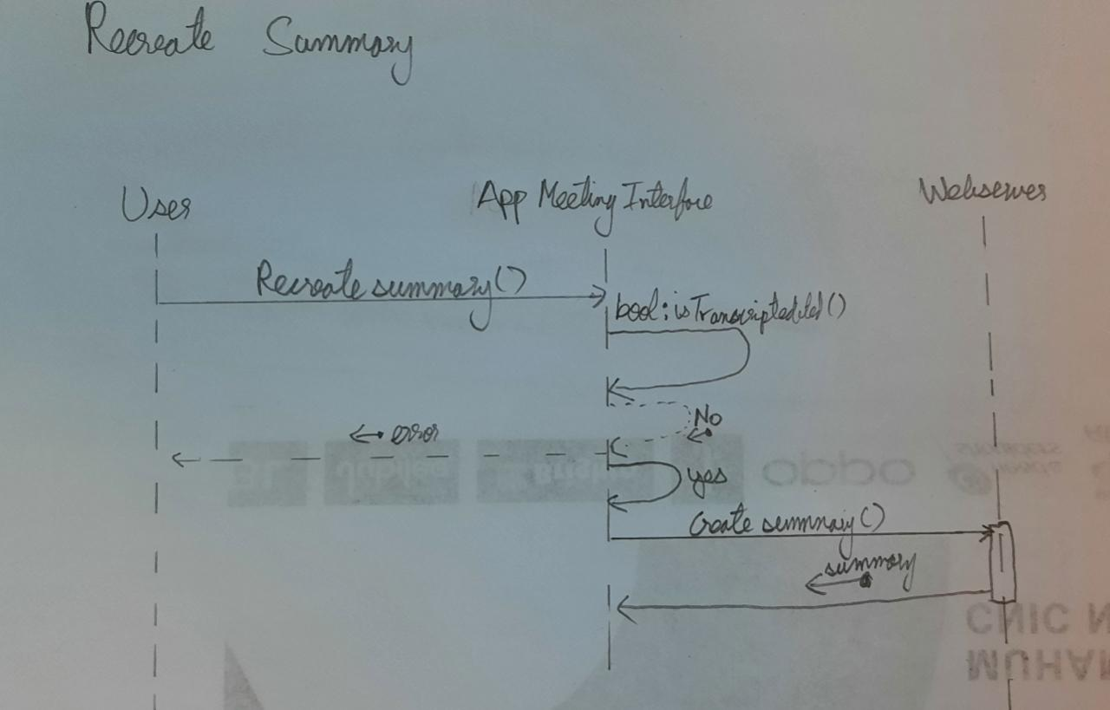

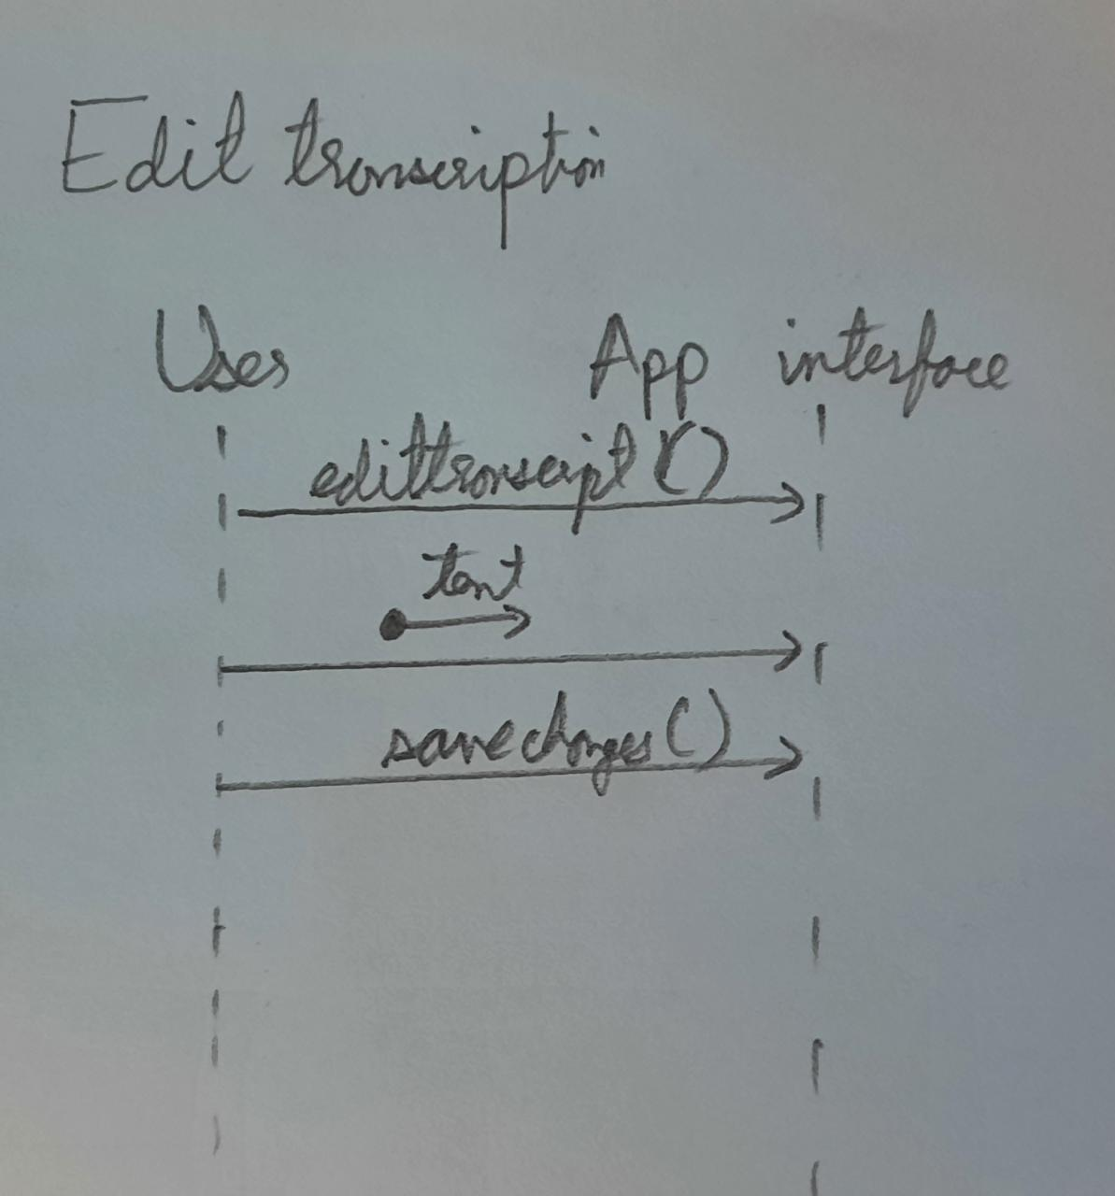

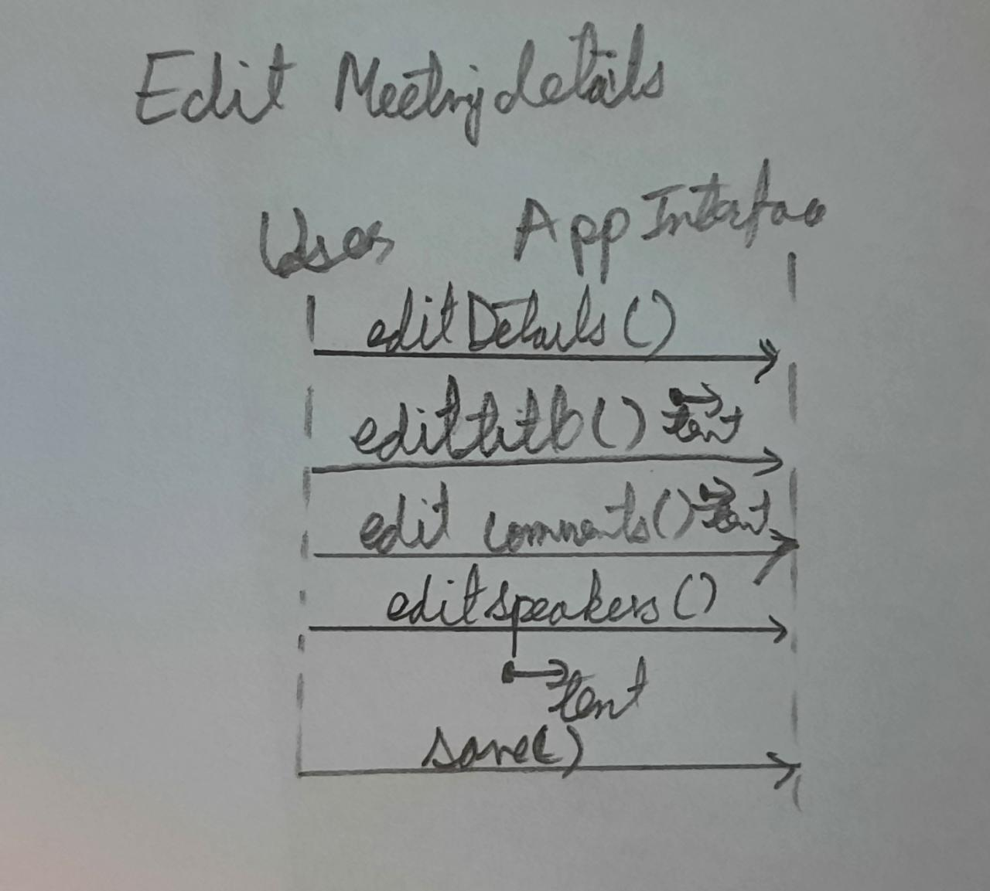

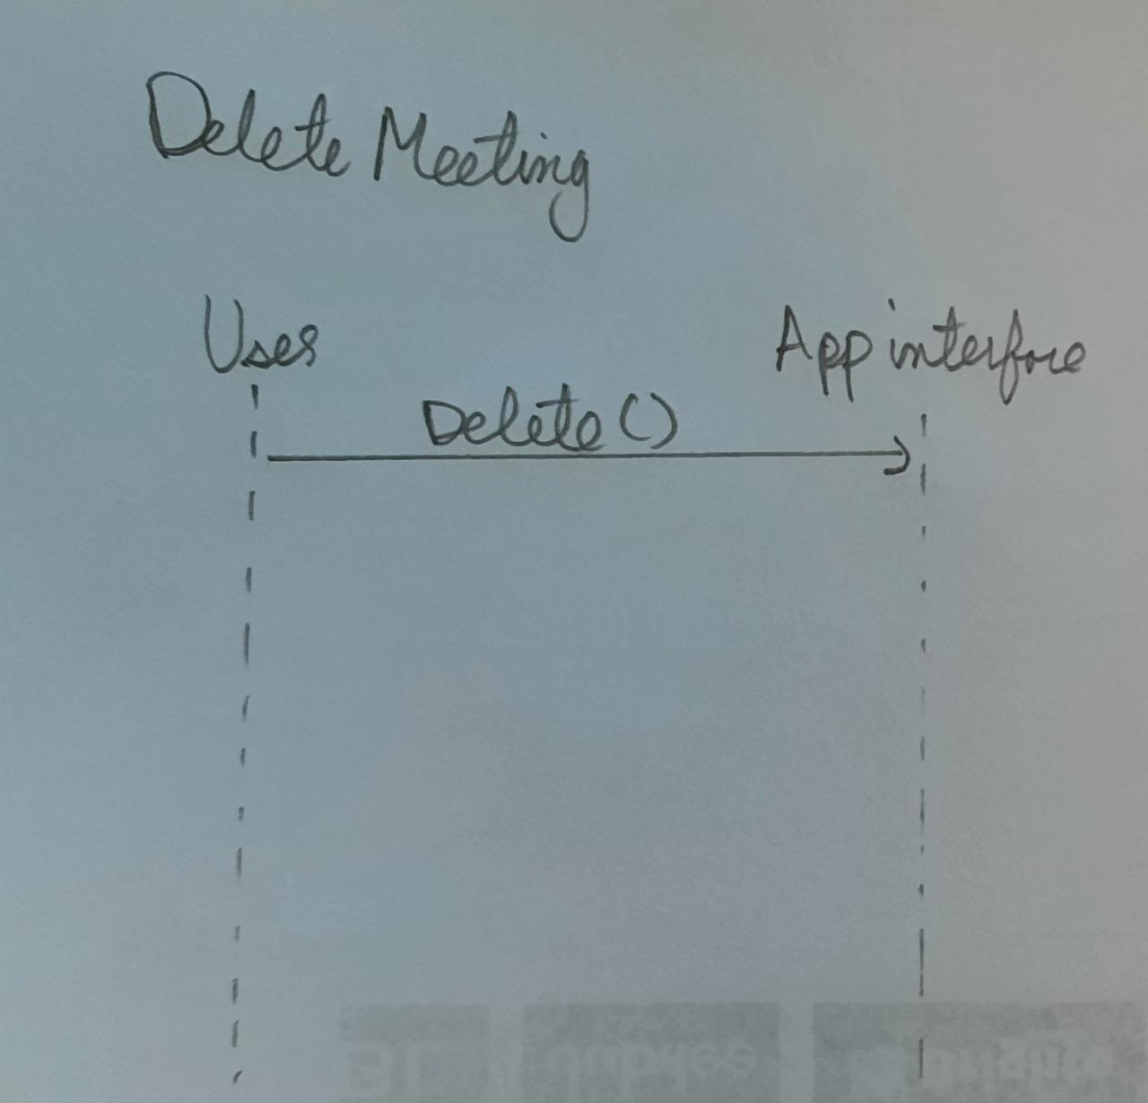

Activity Diagrams

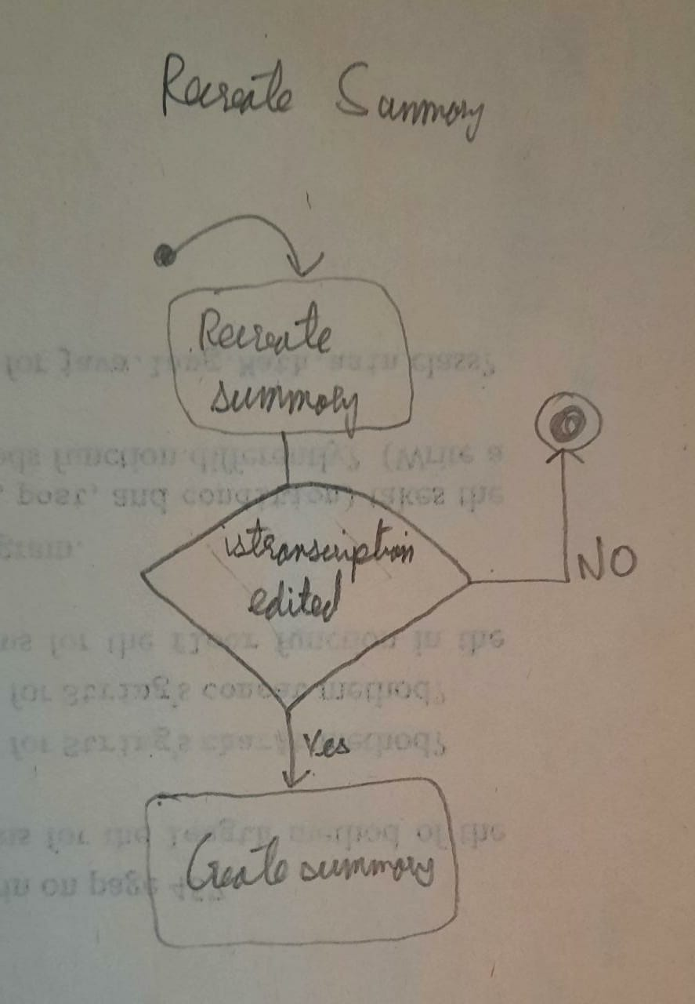
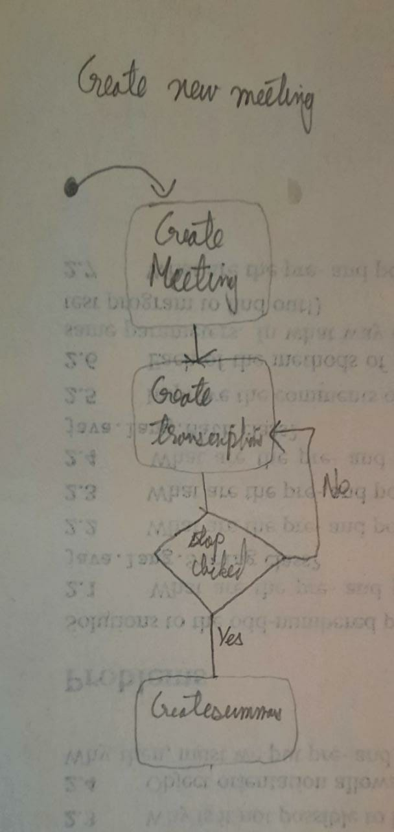
ERD Diagram

